Subject Area/Grade level:
English Language Arts Grade 10

Standard:
Reading: Key Idea and Details
3 ) Analyze how complex characters (e.g., those with multiple or conflicting motivations) develop over the course of a text, interact with other characters, and advance the plot or develop the theme. [RL.9-10.3]
ISTE Standard: Innovative Designer
Students know and use a deliberate design process for generating ideas, testing theories, creating innovative artifacts or solving authentic problems.
ISTE Standard: Knowledge Constructor
3c Students curate information from digital resources using a variety of tools and methods to create collections of artifacts that demonstrate meaningful connections or conclusions.

Objectives:
Students will analyze main character(s)
Students will collaborate to create a sequence organizer of main characters events
Students will engage in class discussions to analyze main character
Students will create a Storyboard with an emphasis on main characters.
Students will share Storyboards with class.

Differentiation Strategies:
This lesson will address the needs of various learning styles by using different formats to reach learners. Visual, auditory and creative needs will be reached by different parts of the lesson. The teacher will also follow all IEP/504 accommodations which exist throughout the classroom. The teacher will also allow more time for struggling students. When needed students can also complete some projects verbally or draw captions and pictures when necessary. Students who wish to go deeper into the lesson can work to incorporate animation into various projects.

Engagement:
Students will begin the lesson by participating in a “Character Trait” Kahoot! quiz. https://create.kahoot.it/details/character-traits/dd8068c0-d87d-4f76-93e5-3bcf367f8eb1. Each student will use an iPad to participate in this activity. Students will work individually in this activity. Students will discuss different traits and attributes given to main characters of books read. The formative assessment for this activity will be data collected from the Kahoot! Quiz.
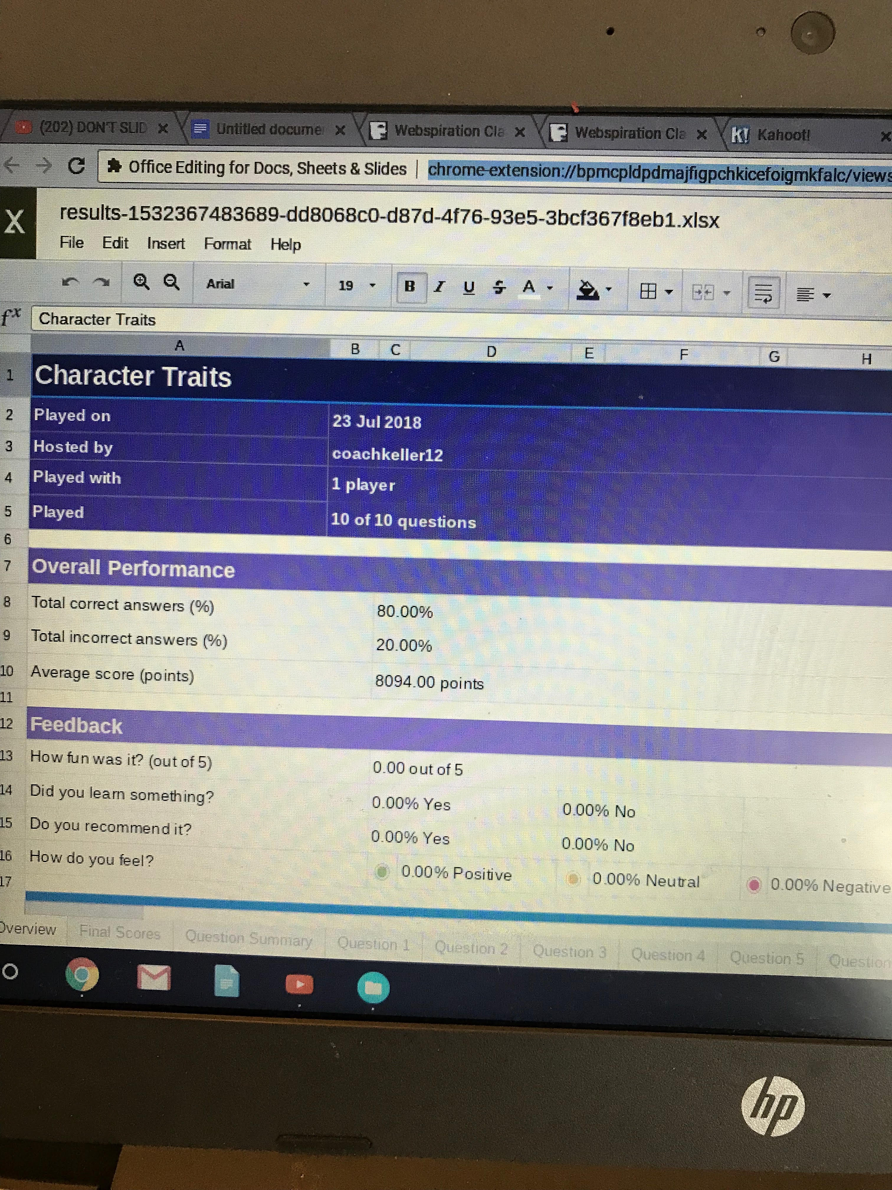

After completing the Character Trait Kahoot! students will watch a 60-second YouTube video which begins to analyze Janie from Zora Neale Hurston’s Their Eyes were Watching God.
https://www.youtube.com/watch?v=_SEKNwDQYLw Students will then answer the five question true/false quiz from Socrative. https://b.socrative.com/teacher/#import-quiz/35188795 This assessment will allow the teacher to evaluate students prior knowledge of Janie and Their Eyes were watching God. (Answers for quiz. 1. False 2. False 3. True 4. False 5. False)

Exploration:
The teacher will share a created character graphic organizer for Janie http://www.webspirationclassroom.com/launch.php 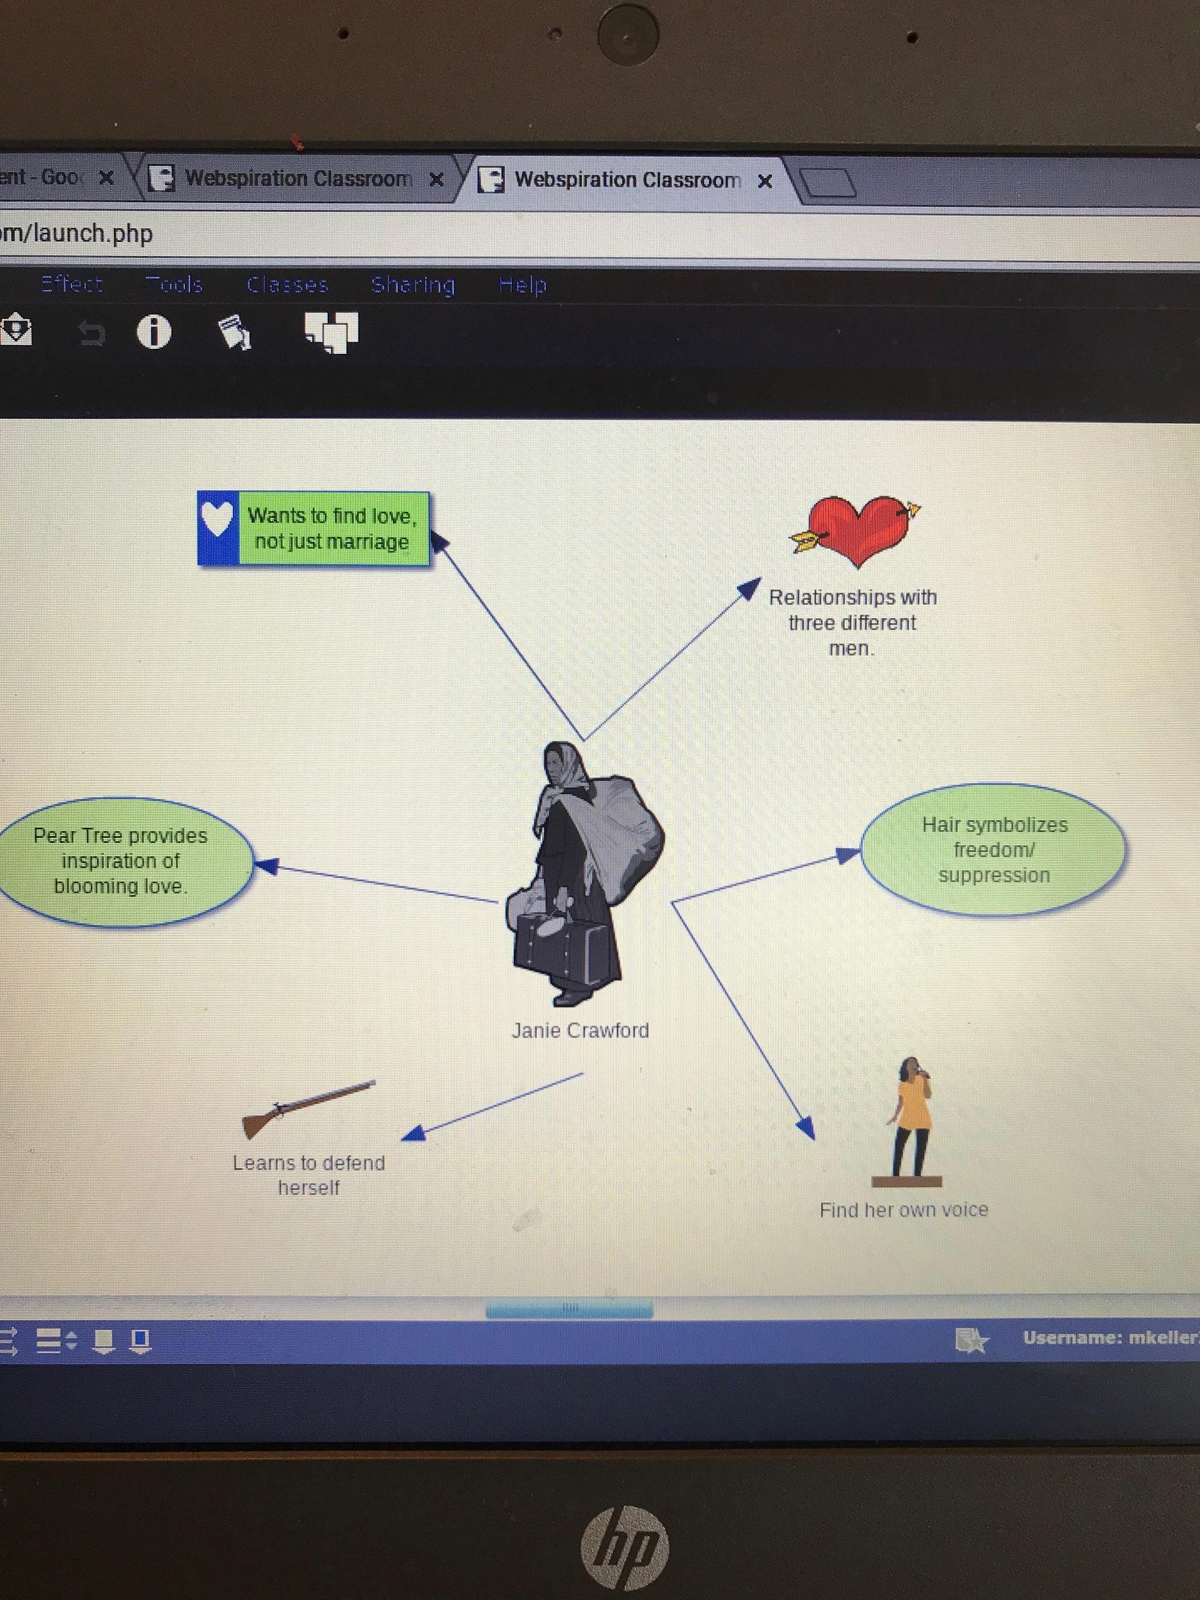Students will then use www.webspirationclassroom.com to individually create a character graphic organizer. The teacher will use a checklist to assess individual graphic organizers. https://docs.google.com/document/d/1qx5ucAcKSWuGiVev08IYicZJD_MBMRezOL7ha68Ppbo/edit?usp=sharing 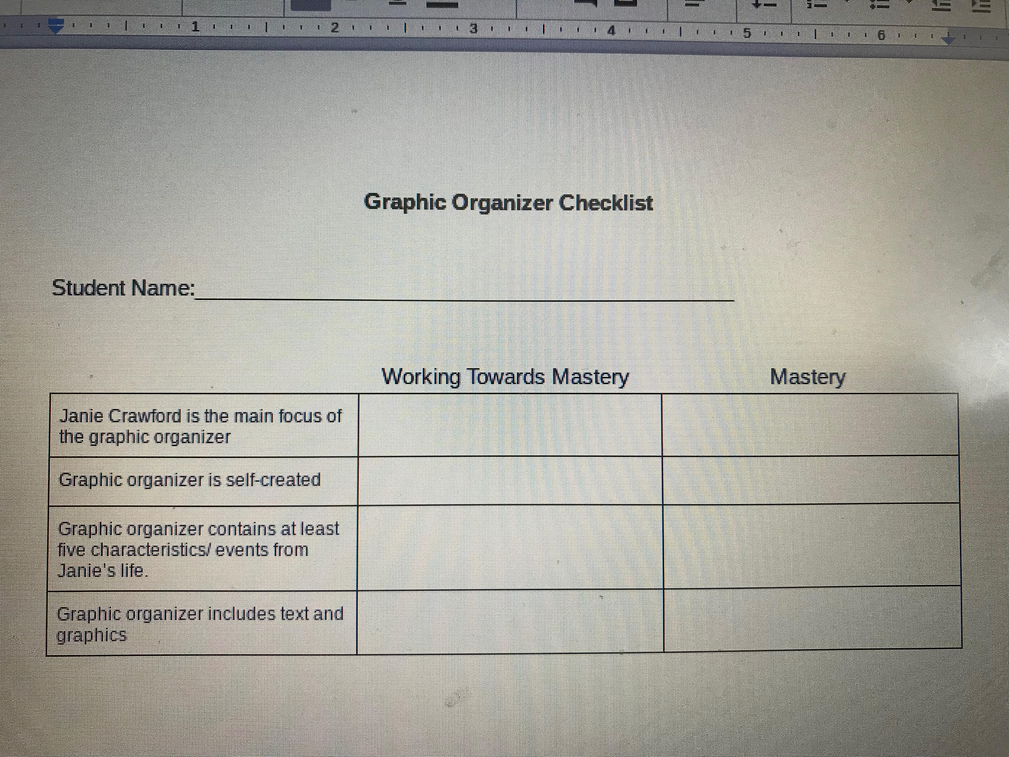
After completing his/her personal graphic organizer students will pair up and work collaboratively to create a sequence organizer of Janie’s life. Students will use Holt Interactive Graphic Organizers to create a Flow Chart of Janie’s life. Students will analyze the text to sequence Janie’s life.
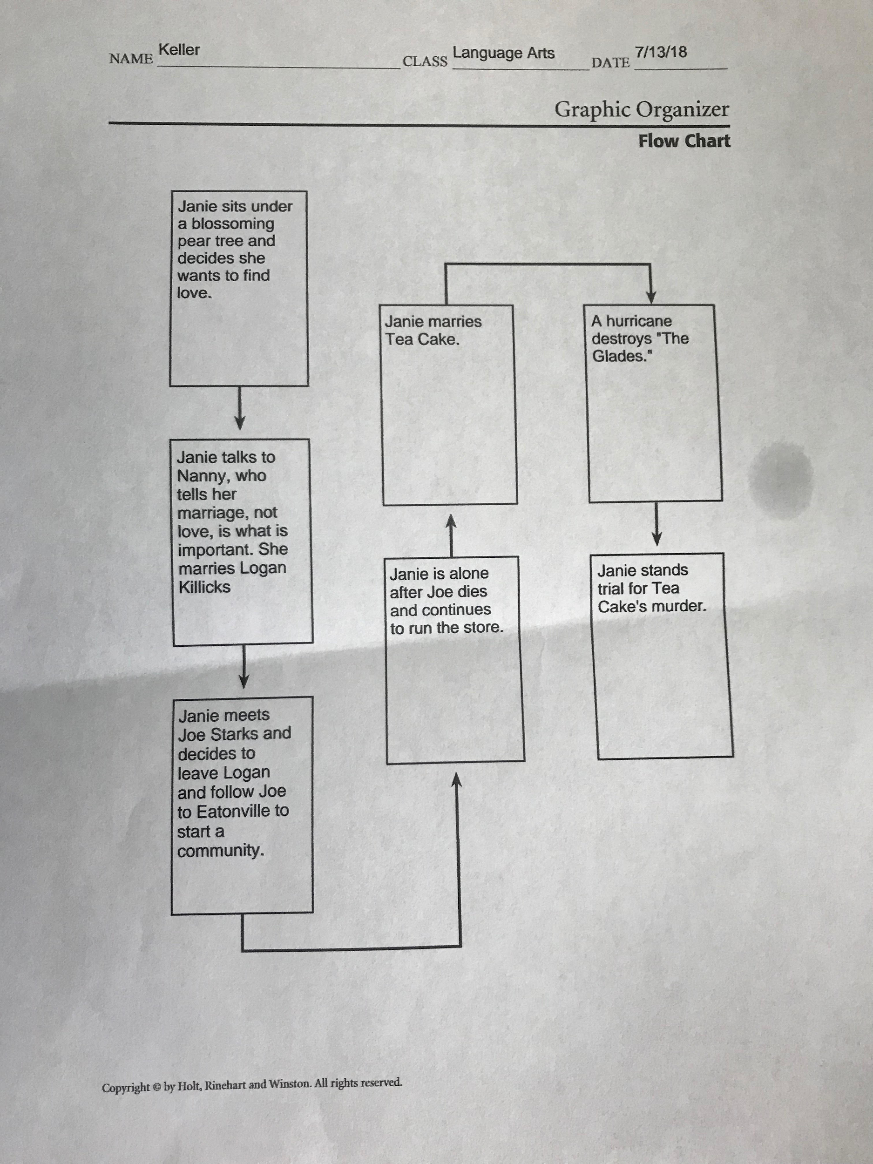
Flow Chart: https://my.hrw.com/nsmedia/intgos/html/PDFs/Flow_Chart.pdf
Students will be given time to turn-and-share their flow charts with other groups. Collaboration sequence organizers will be assessed using a rubric http://rubistar.4teachers.org/index.php?screen=PrintRubric&rubric_id=2757746&
Rubistar #2757746

Explanation:
The teacher will begin the explanation part of the lesson by reviewing some of Janie’s strongest character traits. These will include strength, intelligence and forward-thinking. Students will also review certain vocabulary words such as, pugnacious, temerity, surly and languid. Definitions include: pugnacious- ready and able to resort to force or violence, languid - lacking spirit or liveliness, surly-unfriendly and inclined toward anger or irritation and temerity - fearless daring.
After reviewing character traits and vocabulary words the students will engage in a Prezi presentation covering Janie Mae Crawford. Prezi link: https://prezi.com/view/HwtZrXs4aD57iMMCxcwg/

Elaboration:
https://worditout.com/word-cloud/3205537
Students will create a word cloud analyzing Janie Crawford, or a different character from Their Eyes Were Watching God. Students will use the website www.WordItOut.com to create their individualized word cloud. Students will copy and paste text, or type descriptive words for their character. Students will use the tabs, font, size, layout, color etc. to edit their word cloud. Students will save and email a copy of completed project to the teacher. The teacher will use a rubric to assess word clouds. http://rubistar.4teachers.org/index.php?screen=ShowRubric&rubric_id=2757737&
Rubistar #2757737
The teacher will show students a storyboard depicting the character Sethe from Beloved.
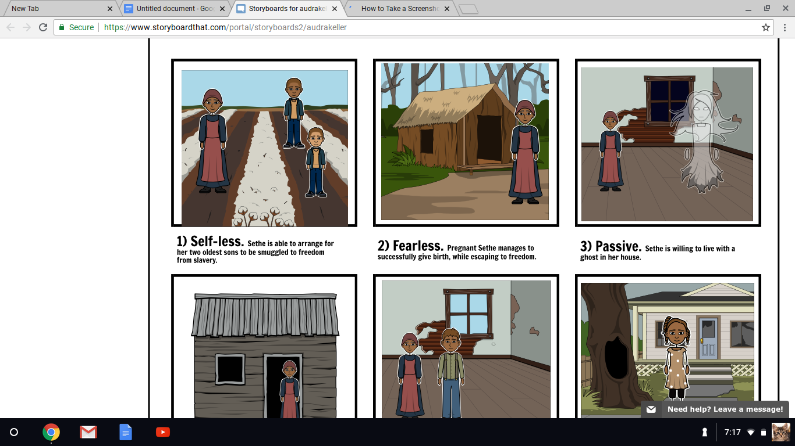 This activity will depict an analyzed character from a previous text. Students will then collaborate and create a storyboard to analyze a character from a previously discussed text.
Students will be instructed to use the website http://www.storyboardthat.com/. After logging in to the website students will work together and choose a template to create a storyboard for a character from a previously discussed text. Students must collaborate to come up with nine descriptive words and sentences to describe their character. Students must also include the plot with their descriptive sentences. The storyboard must also include illustrations, title, name and character picked to analyze. Students will use the “Scene” tab to drag-and-drop a background for each storyboard box. Students will have many options to choose from by picking a topic that best suits their character. After selecting a background scene students will also add the characters needed to bring their storyboard to life. Characters can be found under the characters tab. After clicking the characters tab students will see an assortment of categories available to help bring their story to life. Students can also use other tabs such as, textables, shapes, worksheets and uploads. Each of these tabs gives options for objects which students can drag-and-drop into certain frames. Students can also click on text boxes to add the text needed to analyze their character. After working on their storyboard for approximately fifteen minutes, students will be instructed to save their document. Students will name and save their document and continue working until the storyboard is complete. Students can edit needed pictures and text and preview their storyboard when completed.
The teacher will use a rubric as a formative assessment for this project. http://rubistar.4teachers.org/index.php?&screen=ShowRubric&rubric_id=2757730& Rubistar.4teachers.org #2757730

Evaluation:
- Kahoot! Quiz data.
- YouTube video Socrates True/False Quiz
https://b.socrative.com/teacher/#import-quiz/35188795
Answers: 1. False 2. False 3. True 4. False 5. False
3. Graphic Organizer Checklist
https://docs.google.com/document/d/1qx5ucAcKSWuGiVev08IYicZJD_MBMRezOL7ha
68Ppbo/edit?usp=sharing
4. Flow Chart Rubric # 2757746
http://rubistar.4teachers.org/index.php?&screen=ShowRubric&rubric_id=2757746&
5. Word Cloud Rubric #2757737
http://rubistar.4teachers.org/index.php?&screen=ShowRubric&rubric_id=2757737&
Storyboard Rubric #2757730
http://rubistar.4teachers.org/index.php?&screen=ShowRubric&rubric_id=2757730&

English Language Arts Content - Grade 10

Student Name: ________________________________________

Standard Working Towards Mastery Mastered
1. Determine a theme or central idea of a text and analyze in detail its development over the course of the text, including how it emerges and is shaped and refined by specific details; provide an objective summary of the text. [RL.9-10.2]
2. Analyze how an author's choices concerning how to structure a text, order events within it (e.g., parallel plots), and manipulate time (e.g., pacing, flashbacks) create such effects as mystery, tension, or surprise. [RL.9-10.5]
3. Analyze the representation of a subject or a key scene in two different artistic mediums, including what is emphasized or absent in each treatment (e.g., Auden's "Musée des Beaux Arts" and Breughel's Landscape with the Fall of Icarus). [RL.9-10.7]
4. Determine the meaning of words and phrases as they are used in a text, including figurative, connotative, and technical meanings; analyze the cumulative impact of specific word choices on meaning and tone (e.g., how the language of a court opinion differs from that of a newspaper). [RI.9-10.4]
5. Analyze various accounts of a subject told in different mediums (e.g., a person's life story in both print and multimedia), determining which details are emphasized in each account. [RI.9-10.7]
6. By the end of Grade 10, read and comprehend literary nonfiction at the high end of the Grades 9-10 text complexity band independently and proficiently. [RI.9-10.10]
7. By the end of Grade 10, read and comprehend literary nonfiction at the high end of the Grades 9-10 text complexity band independently and proficiently. [RI.9-10.10]
8. Produce clear and coherent writing in which the development, organization, and style are appropriate to task, purpose, and audience. (Grade-specific expectations for writing types are defined in standards 21-23 above.) [W.9-10.4]
9. Develop and strengthen writing as needed by planning, revising, editing, rewriting, or trying a new approach, focusing on addressing what is most significant for a specific purpose and audience. (Editing for conventions should demonstrate command of the first three standards in the Language strand in Grades K-10.) [W.9-10.5]
10. Use technology, including the Internet, to produce, publish, and update individual or shared writing products, taking advantage of technology's capacity to link to other information and to display information flexibly and dynamically. [W.9-10.6]

ISTE Standards for Students

Name:________________________________________________________

Standard Incomplete Working toward mastery Mastery
Empowered Learner
Students leverage technology to take an active role in choosing, achieving and demonstrating competency in their learning goals, informed by the learning sciences.
Digital Citizen Students recognize the rights, responsibilities and opportunities of living, learning and working in an interconnected digital world, and they act and model in ways that are safe, legal and ethical.
Knowledge Instructor Students critically curate a variety of resources using digital tools to construct knowledge, produce creative artifacts and make meaningful learning experiences for themselves and others.
Innovative Designer Students use a variety of technologies within a design process to identify and solve problems by creating new, useful or imaginative solutions.
Computational Thinker Students develop and employ strategies for understanding and solving problems in ways that leverage the power of technological methods to develop and test solutions.
Creative Communicator Students communicate clearly and express themselves creatively for a variety of purposes using the platforms, tools, styles, formats and digital media appropriate to their goals.
Global Collaborator Students use digital tools to broaden their perspectives and enrich their learning by collaborating with others and working effectively in teams locally and globally.

